* Deliverable 1: Outcomes-Based on Launch Date Chart  
  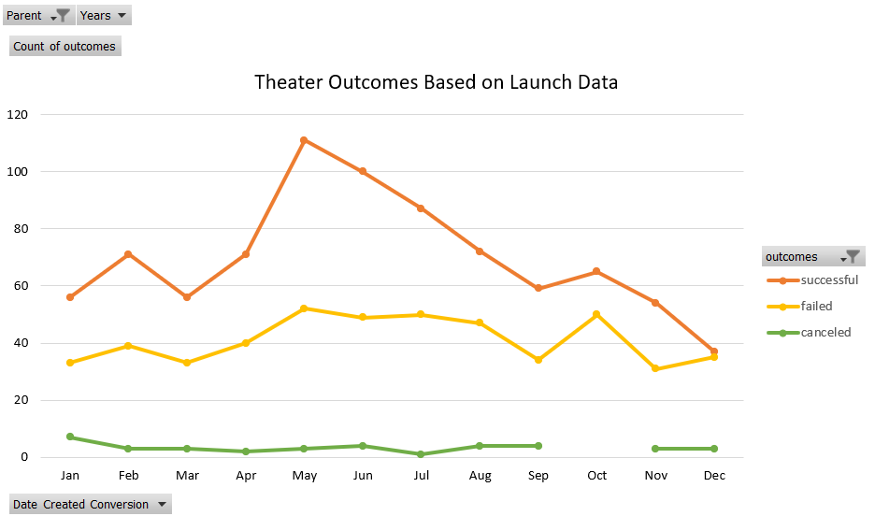
* Deliverable 2: Outcomes-Based on Goals Chart  
  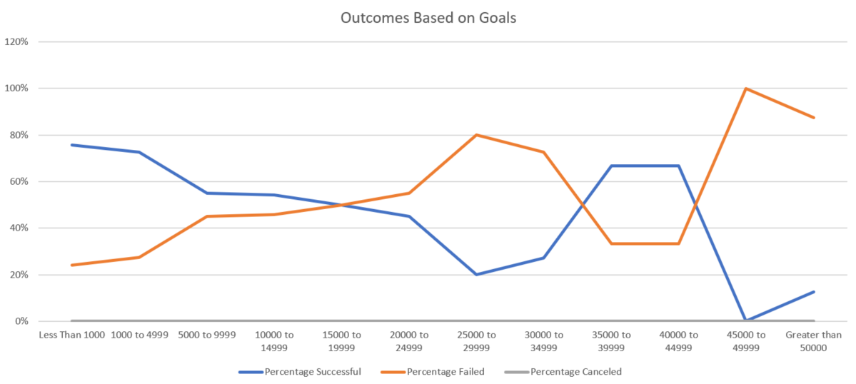
* Deliverable 3: A written analysis of the results
  + What are two conclusions you can draw about the Outcomes-based on Launch Date?
  1. During the year, May has the highest count of successful outcomes. 2. Q2 ( April, May, and June) has the best performance, more successful outcomes, and Q4 is the weaker performance, less successful outcomes. Overall failed and canceled outcomes are stable, not fluctuating by season.
  2. What can you conclude about the Outcomes-based on Goals?

The higher the goals set, the higher chance to fail (less successful outcomes), besides the range of $35,000 to $44,999.  This range might be a sweet spot for the organizer, which has a higher success rate, as well as higher outcomes.

* 1. What are some limitations of this dataset?

The goals and the pledge have a big range, from $1 to $1MM, which might lead to potential outliners.

* 1. What are some other possible tables and/or graphs that we could create?

We can also look into the successful outcomes based on event categories, create a pie chart.  
That way the organizer knows which events have higher chances to get successful outcomes. 